All students expecting to graduate must submit an Application for Degree Form. Log into myUTH and select the “Apply for Graduation” link located in the Self Service area.
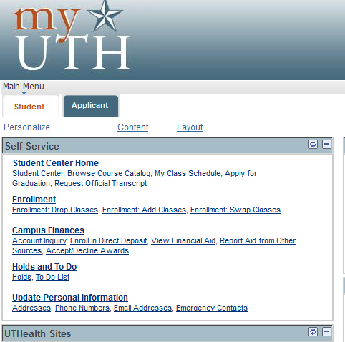
Upon successful completion of your Application for Graduation the following will appear.
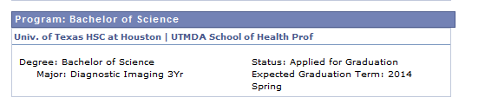
Candidates are expected to complete this process during the registration period for the term in which you expect graduate.
The Graduation Fee - published in the Tuition and Fee Schedule - will be assessed at this time. The fee is non-refundable.
Students can specify how they want their name printed on the diploma by submitting ag a Diploma Name Request form to the Registrar's Office. Diploma names which differ from the student's office name in myUTH must meet certain requirements.
The form and additional information can be found at Current Students>Graduation>

