
ALARA Program

ALARA stands for As Low As Reasonable Achievable. It is a concept that emphasizes the importance of minimizing the dose received when working with or around radioactive material. The three major principles used to keep doses ALARA are Time, Distance, and Shielding.

Minimize Time 

- Dose received is directly proportional to amount of time spent near radiation source
- The shorter the amount of time spent around RAM, the lower the dose
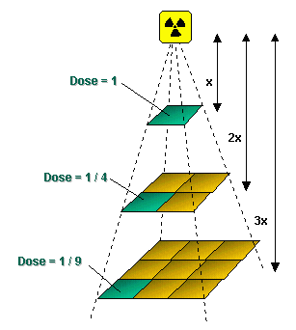
- Use RAM only when necessary
- Perform dry runs

Increase Distance 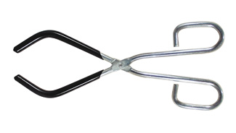

- Inverse square law
  - Double distance from RAM -> Decrease dose by 4
  - Triple distance from RAM -> Decrease dose by 9
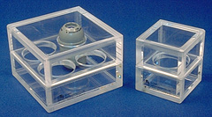
- Use tongs, tweezers, pipettes, etc

Shielding 
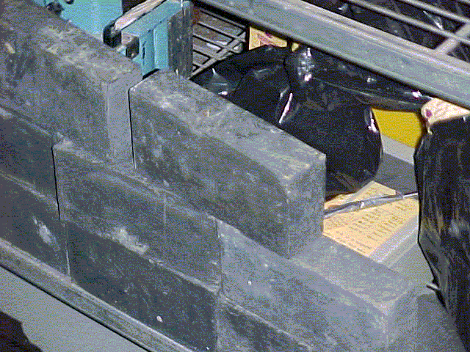
- Certain materials “absorb” certain types of radiation
- Use proper shielding
  - Betas -> Plexiglas
  - Gammas and X-rays -> Lead

For more information see Radiation Safety Manual Section 6.1 ALARA Principal
http://www.uth.tmc.edu/safety/radsafety/rsdmanual.htm

