Caution Radiation Stickers

The following symbol shall be used for describing radioactive materials. The symbol shall use the colors magenta, purple, or black on a yellow background.

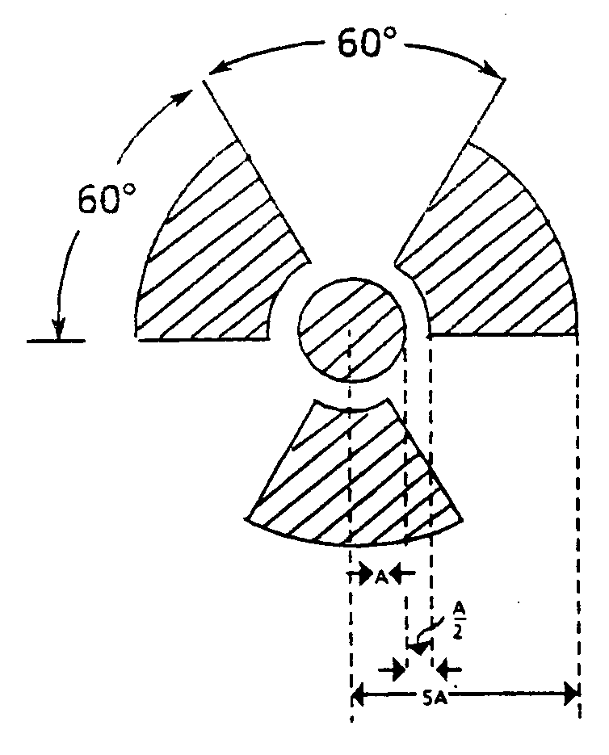

Areas involved with radiation will have posted caution stickers for warning.

Caution Radiation Area - any area, accessible to individuals, in which radiation levels could result in an individual receiving a dose equivalent in excess of 5 mrem in 1 hour at 30 centimeters from the source of radiation or any surface the radiation penetrates.

Caution Radioactive Material - should be posted at all doors or entrances to rooms or areas in which licensed radioactive materials are used or stored (excluding natural uranium, thorium, ⁶³Ni, and other exempt sources).

